REQUEST FOR QUOTATION SHORT FORM

Attention: |  | From: | Mitul Desai
Organisation: |  | Organisation: | Burdekin Shire Council
Address: |  | Address: | 145 Young Street,  AYR QLD 4807
Telephone No: |  | Telephone No: | (07) 4783 9800
Your Ref: |  | Our Ref: | QBSC/22/012 – Purchase and remove mulch from Ayr Transfer Station, Home Hill Transfer Station, Giru Transfer Station and/or Kirknie Landfill
Email: |  | Email: | enquiries@burdekin.qld.gov.au
No Pages Sent: |  | Date: | 11 March 2022
QUOTATION TITLE: QBSC/22/012 – Purchase and remove mulch from Ayr Transfer Station, Home Hill Transfer Station, Giru Transfer Station and/or Kirknie Landfill

An invitation is extended to submit a written quotation for the above hereinafter called “the services”.

Quotations must be in accordance with the attached Specification and Criteria. Please ensure your written Quotation is lodged prior to the Closing Time, being Thursday 24 March 2022 at 12 Noon.

Thank you in anticipation of receipt of your written Quotation. You will be advised if you have been selected as the successful Respondent in due course.

In the meantime, please direct any general and Specification enquiries to Mitul Desai on telephone (07) 4783 9800.

Yours sincerely

Mitul Desai
Coordinator Waste Services
CRITERIA

The Criteria listed below must be addressed and detailed information provided as part of your written Quotation:

Item | Criteria Description
1 | Completion of the attached Form of Quotation and Price Schedule (refer to Items 1 & 2)
2 | Compliance with Special Conditions (refer to Item 3)
3 | Compliance with Specification (refer to Item 4)
4 | Insurance  The successful Respondent and any subcontractor(s) will be required to effect and maintain insurance policies in the following sums:  - Public liability insurance in the sum of at least $10,000,000.00 in respect of any one occurrence and for an unlimited number of claims.  - Workers Compensation or Personal Accident Insurance cover as required by law (whichever may apply).

The following Local Government documents will apply to the successful Respondent and may be viewed on request:

      - Contractor Work Health and Safety Policy/Commitment Statement

- FORM OF QUOTATION

To: The Chief Executive Officer
Burdekin Shire Council
PO Box 974
AYR QLD 4807

Attention: Mitul Desai

I/We the undersigned hereby provide a Quotation for the services requested. The quoted consideration is as provided in the Price Schedule submitted with this Quotation.

DATED this day of 2022

Name of Respondent:

Full Name of Company:

Address of Company:

Contact Details Phone Number

Mobile Phone Number:

E-mail:

- PRICE SCHEDULE
Note: For clarification purpose, the price tendered is an offer to pay the Council for the right to purchase and remove the mulch
Description |  | Nominated Volume (m3) | Price Tendered per m3  (ex GST) | GST Component | Price Tendered per m3  (inc GST)
- Ayr transfer station
- Home Hill Transfer Station
- Giru Transfer Station
- Kirknie Landfill
Separate price for Location (a), (b), (c) and (d) combined.

Completion Schedule

Guaranteed time of removal from acceptance of offer _________________________________

Signature:
Full Name:
Date:

- SPECIAL CONDITIONS
  - Quoted prices
    - Prices quoted are to be on a lump sum basis for the purchase and removal of mulch for the period to 24 March 2023

    - All prices for goods and/or services offered are to be fixed for the term of the Contract. Quoted prices must include Goods and Services Tax (GST).

3.1.3 Any charge not stated in the Quotation as being additional will not be allowed as a charge for any transaction under any resultant Contract.
  - Lodgement of Quotations
3.3.1 The Respondent must submit the original of the Form of Quotation;
3.2.2 Quotations must be submitted duly signed and in a sealed envelope clearly endorsed with the Quotation Title and Reference Number and must be placed in the Tender box in Council administration offices and addressed to:
The Chief Executive Officer
Burdekin Shire Council
145 Young Street
AYR QLD 4807

Attention: Mr Mitul Desai
3.2.3 Email quotations will be accepted if the email is received by the due date and time. Quotation number and title is to be provided in the subject line and sent to: enquiries@burdekin.qld.gov.au
  - Quotation Closing Time
3.3.1 Quotations close on Thursday 24 March 2022 at 12 Noon in Australian Eastern Standard Time.
3.3.2 Only those Quotations received by the Closing Time will be considered.
3.3.3 The Local Government reserves the right to consider a quotation which is not submitted by the Closing Time if, in the opinion of the Local Government, there is satisfactory evidence that the delay in receiving the quotation was due to matters not caused by the Respondent.
  - Informal Quotation
Any Quotation may be rejected if it:
- does not comply with the requirements of the Specification or this Request for Quotation; or
- is not accompanied by a conforming quotation; or
- contains any provisions not required by this Request for Quotation.
  - Acceptance of Quotations
3.5.1 The Local Government is not bound to accept the lowest or any Quotation.
3.5.2 The Local Government may accept part of a Quotation.
3.5.3 Quotations will be evaluated by reference to the criteria in Section 104 of the Local Government Act 2009, namely:
- Open and effective competition.
- Value for money
- Encouragement of the development of competitive local business and industry;
- Environmental protection; and
- Ethical behavior and fair dealing.
3.5.4 This Request for Quotation together with the Local Government’s written acceptance of the Quotation, shall constitute the Contract between the Local Government and the successful Respondent.
3.5.5 The Respondent agrees that the Quotation will remain open for acceptance for a minimum period of 60 days after the Closing Time, notwithstanding that there may have been negotiations in respect of any Quotation in the meantime.
3.5.6 A Respondent may withdraw its Quotation at any time after the expiration of 60 days from the Closing Time but must not withdraw their Quotation prior to the expiration of 60 days from the Closing Time.
  - Contract Duration
3.6.1 The Contract is to be completed following removal of mulch and any associated plant and equipment from the Council land as negotiated and agreed by the Local Government.
3.6.2 However, in the event of the successful Respondent failing in any manner to carry out the Contract to the Local Government’s satisfaction, the Local Government may forthwith determine the Contract by written notice to the successful Respondent.
3.6.3 Successful bidders will be allowed to purchase and remove additional mulch quantities that remains unallocated under the quotation process, provided it is agreed in writing with Council.
  - Canvassing of Elected Members and Council Officers
Canvassing of elected members or Council officers will automatically lead to disqualification.
  - Indemnity
The successful Respondent must indemnify and keep indemnified the Local Government against:
- any liability under the Workers’ Compensation and Rehabilitation Act 2003 as amended from time to time; and
- any other law in force or which during the term of this Contract may come into force, under which any person is entitled to claim or sue for compensation or recover any damages from the Local Government.

- SPECIFICATION
  - Introduction
4.1.1 The Contractor is required to purchase, load and remove mulch from the Ayr Transfer Station, Home Hill Transfer Station, Giru Transfer Station and Kirknie Landfill. The contractor may quote to remove certain volumes from selected locations

4.2 Site Location

4.2.1 The project includes the removal of product from the following locations

Ayr Transfer Station
2A-4A Railway Street, AYR
Estimate > 10,000m³ mulch

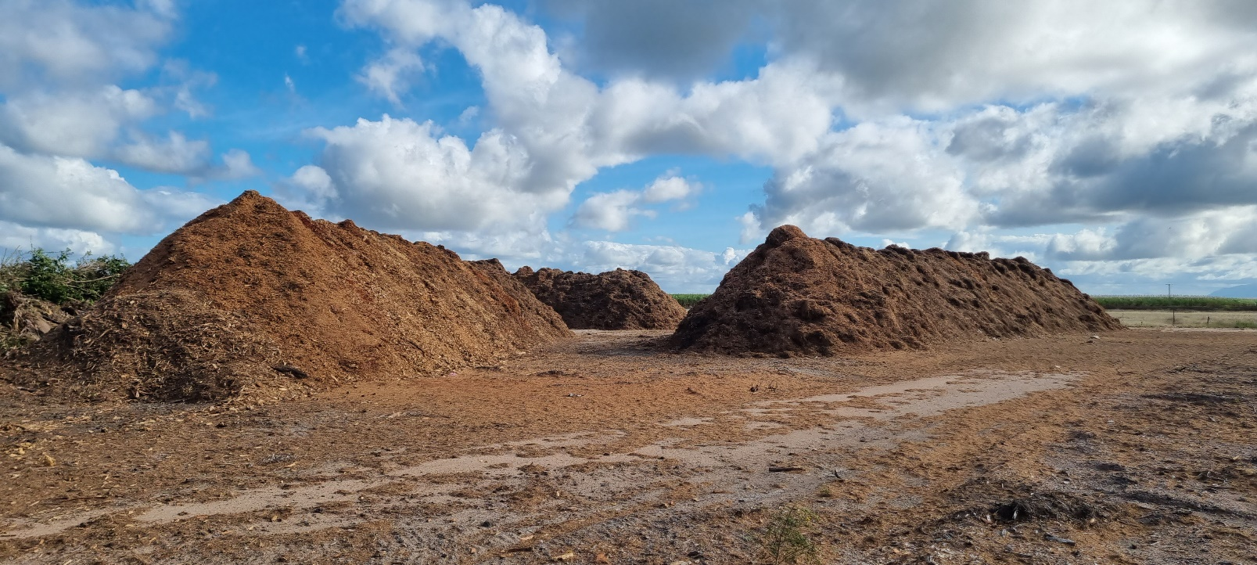

Home Hill Transfer Station
80 Bojack Road, HOME HILL
Estimate > 3000m³ mulch
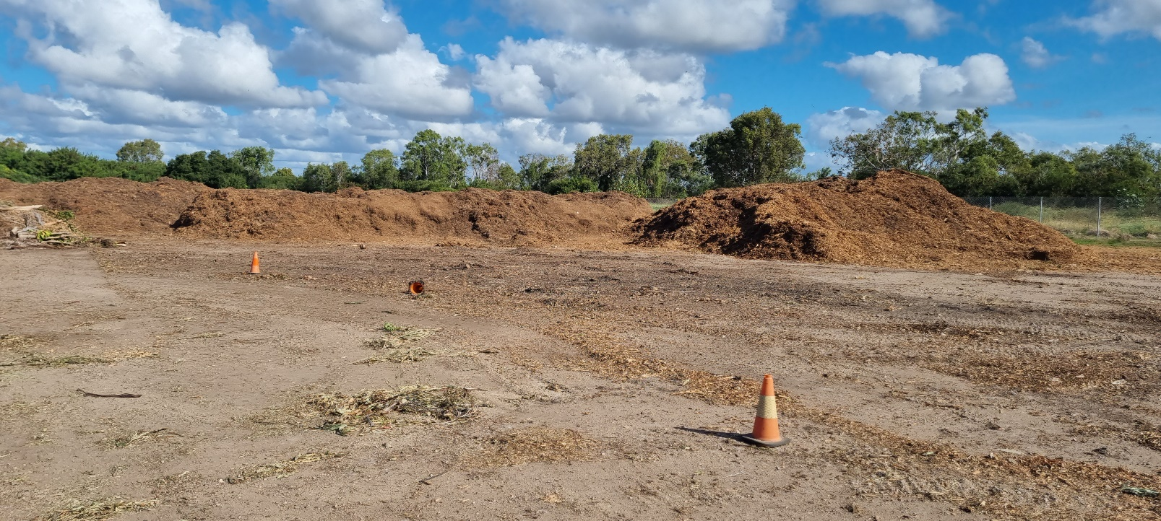

Kirknie Landfill
1614 Kirknie Road, KIRKNIE
Estimate > 2000m³ mulch

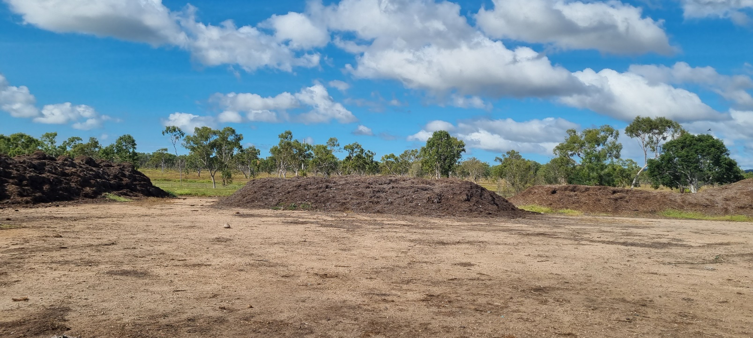

Giru Transfer Station
Cromarty Boat Ramp Road, GIRU
Estimate 60m³ mulch

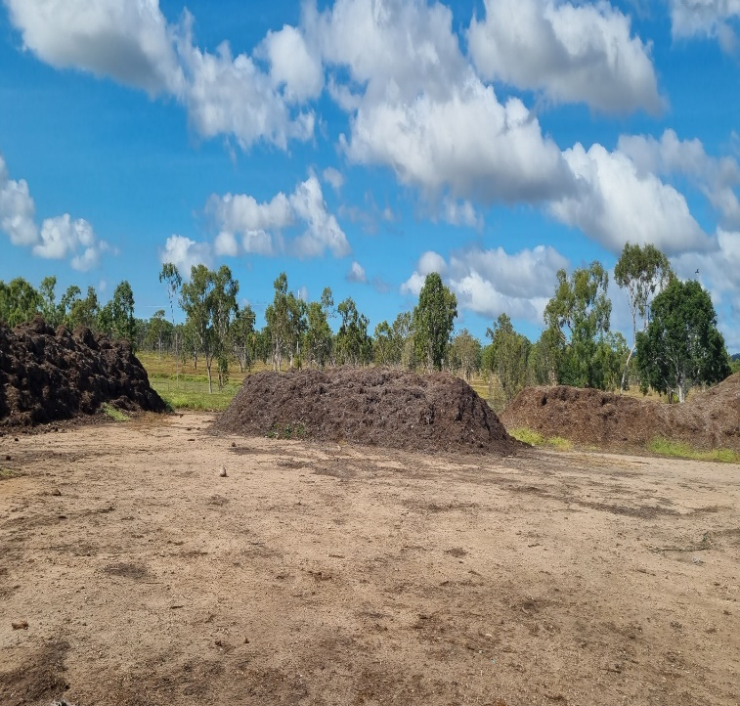

4.3 Scope of Works

4.3.1 Inspection of material is recommended. Any interested respondent is to contact Mitul Desai on 4783 9800 to advise when they will be inspecting the locations.

4.3.2 Quotations are to be for the purchase and removal of mulch products listed above.
4.3.3 Any variations are to be considered at the discretion of Council and agreed upon in writing.
4.3.4 All sites are to be left in a clean and tidy condition on completion of contract.
4.3.5 Council will not be responsible for the payment of any expenses or losses incurred as a result of undertaking this work.
4.3.6 Works are to be conducted in a manner that shall comply with the Work Health and Safety Act 2011, associated Regulations and such relevant Federal, State and Local Laws as are applicable to the work.

4.3.7 All plant and equipment utilised to undertake this work shall be of such standard so as to comply with the Work Health and Safety Act 2011, applicable workplace health and safety regulations and advisory standards.
END

